**Chapter 1 Client**

This section enables you to set up the client’s details and manage client based on company requirement.

*In this Chapter:*

**1.1 New Client**

**1.2 Manage Client**

**1.1 New Client**

This function enables you to set up the general information of your client, in case client maybe a person or a company so that if that is a company client information may including some statistical details about company. These data will be used by various routines in the system.

* To open New Client, on the **SmartLeg@l** navigation, click **Client** and go to **New Client** then click the tab you want to type in information.

**New Client – General Information**

* Red Highlighted text box like Client Name, Category and Register Date cannot be blank
* It is advisable for individual client to key in the New IC No. because system will detect whether the IC No. already registered or not.
* Key in all the neccassary information.

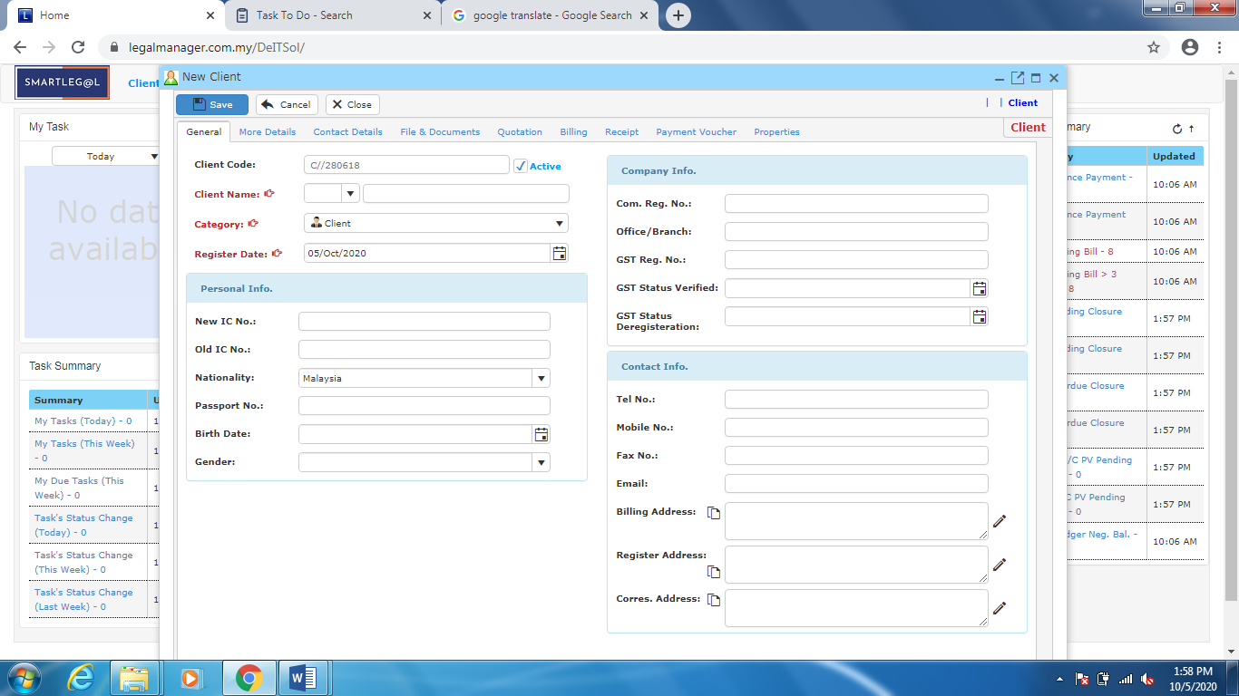

Figure: New Client – General

* In case for individual client you can select Mr., Ms. or Madam title before entering client’s name

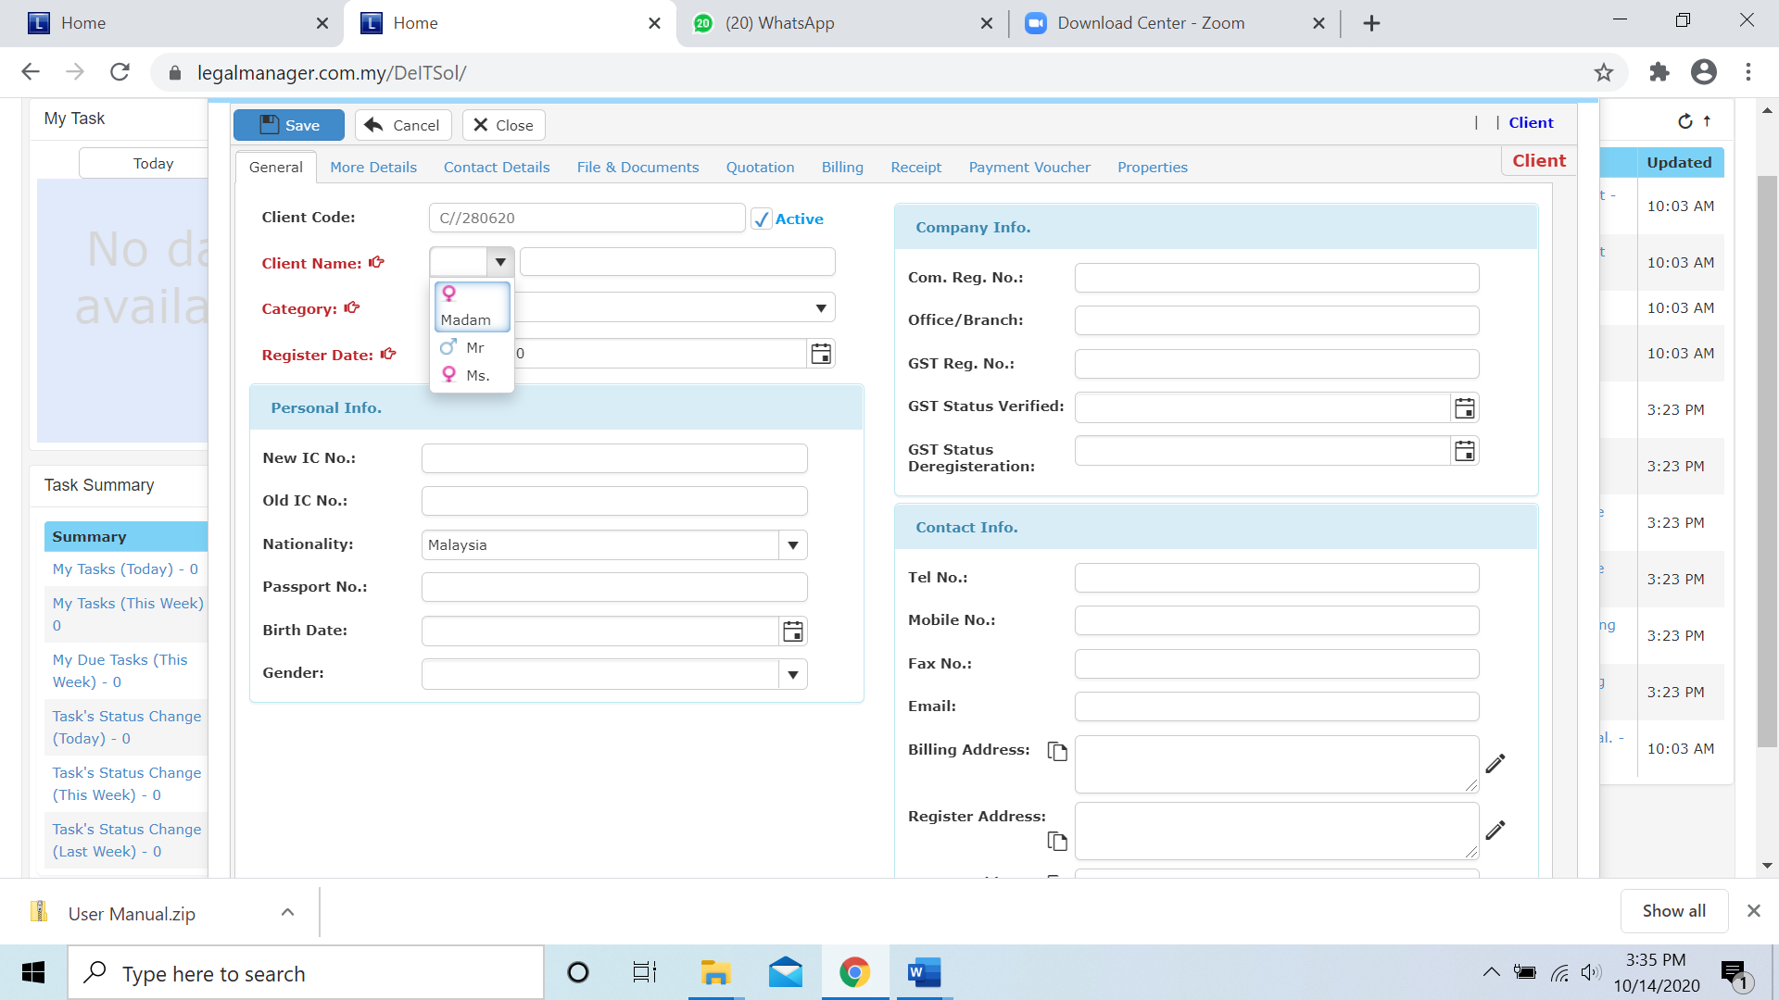

Figure: New Client -General – Client’s title

* You can select a category of your client from the drop-down box when you click to category

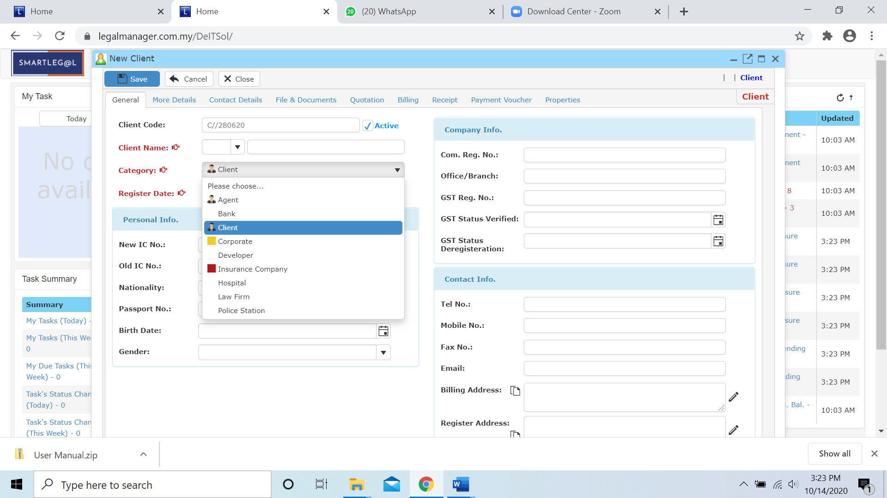

Figure: New Client -General - Category

* Register date will auto fill the date you create new client by default other than key in the register date, as a prevention for key in wrongly you can fill the date with using calendar

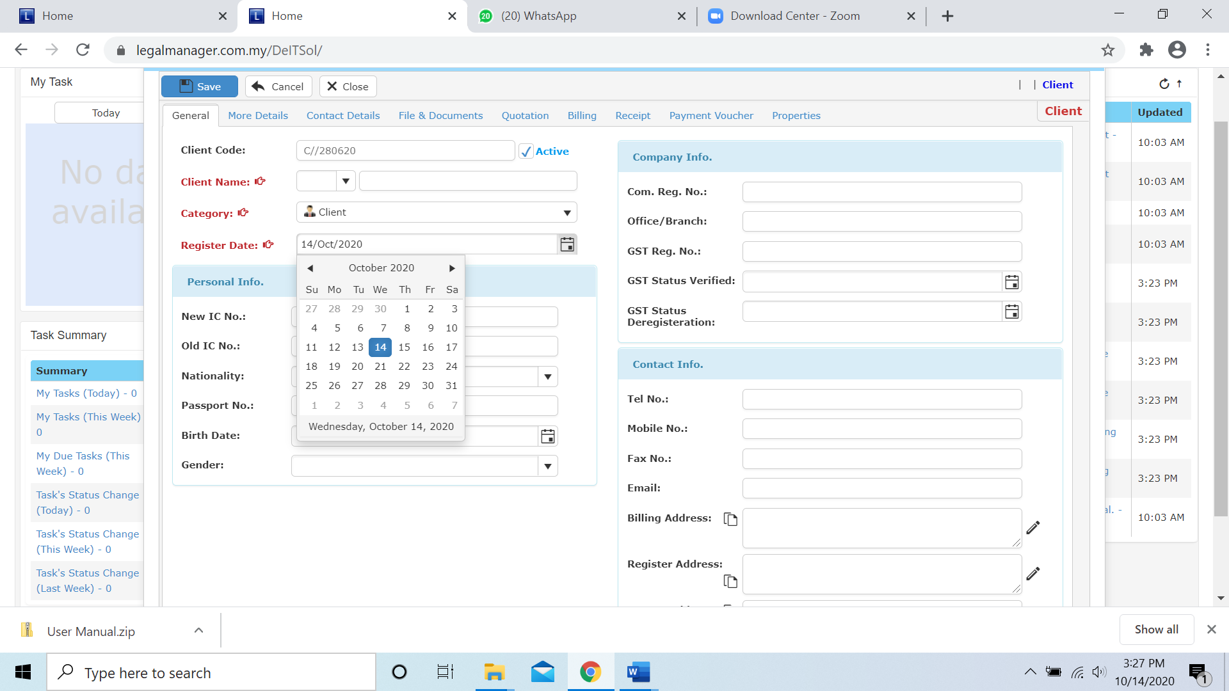

Figure: New Client -General – Register Date - Calendar

**New Client – More Details**

* Fill more details about your client.

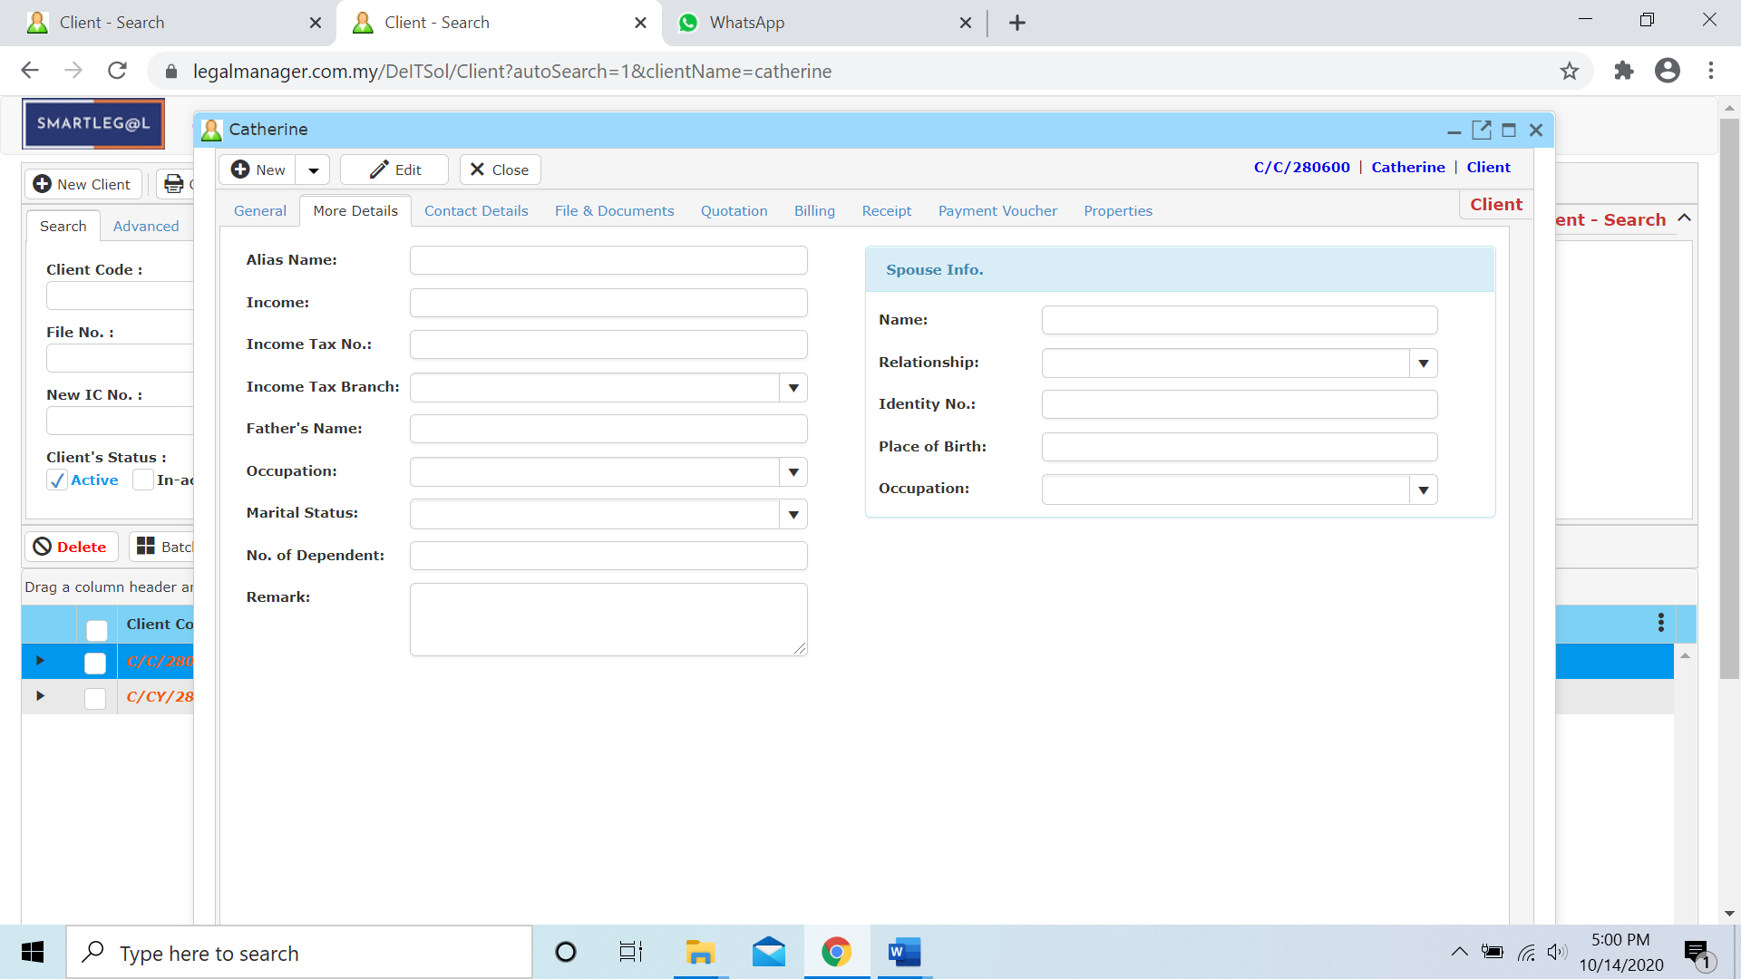

Figure: New Client – More Details

**New Client – Contact Details**

* You are required to have an existing client record or create a new client before adding client contact.
* There are 6 remarks fields provided for user to input useful data.

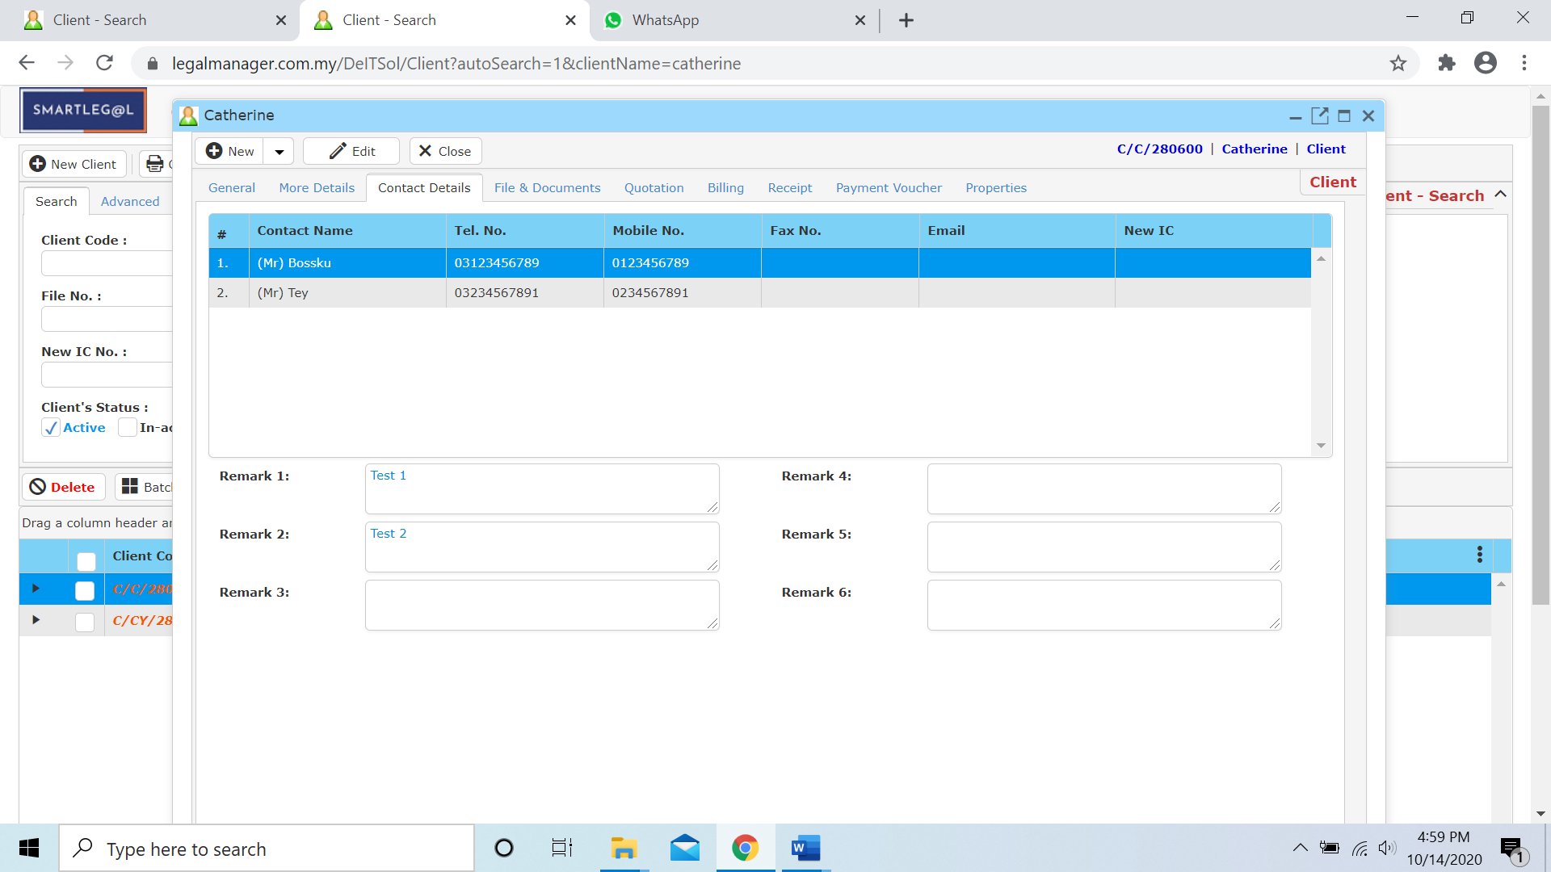

Figure: New Client – Contact Details

* Every contact provided by client can be added in with the **New Contact**’ button, after you click that, ‘Figure:New Client – Contact Details – New Contact Input Form’ will show up. In addition, the contact can be ‘**Edit**’ or ‘**Remove**’as well.

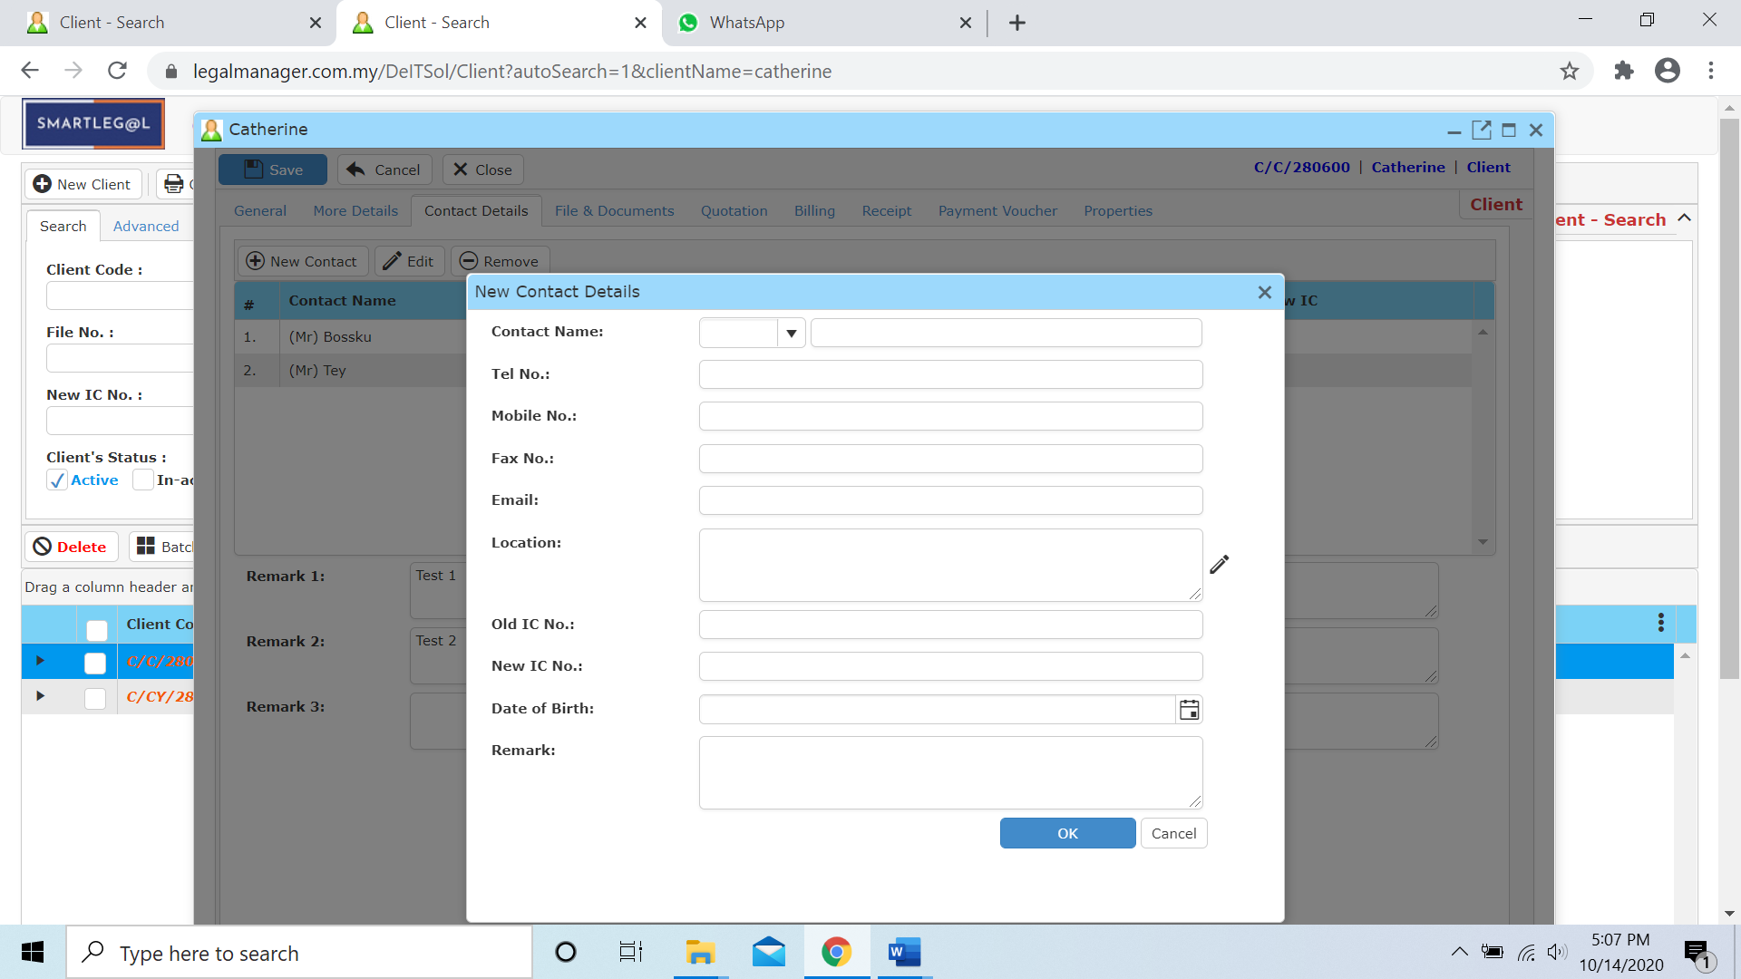

Figure: New Client – Contact Details – New Contact Input Form

**New Client – File & Documents**

**Register New File Master at Client Master**

* You are required to have an existing client record or create a new client before opening a new file.
* Click ‘**New File Master**’.
* Please refer to ‘chapter 2 – Create new File’.

## Documents at Client Master

* First, you are required to search an existing client.
* Select ‘**File & Document**’ tab.
* Client files will be displayed at the tree view.
* Click ‘**Download(zip)**’ to download files in zip version

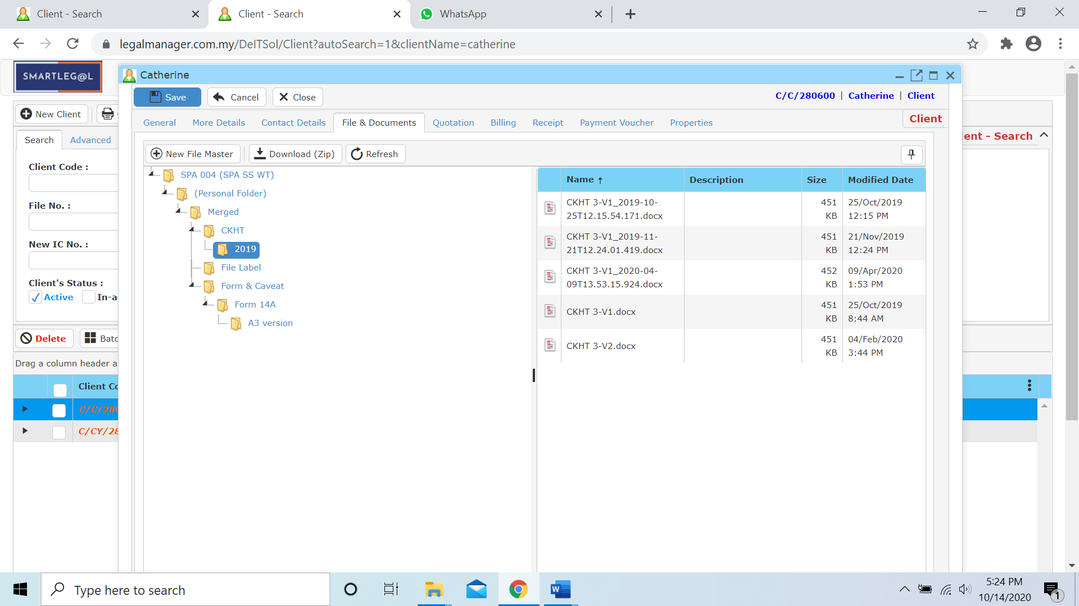

Figure: New Client – File & Documents

**New Client – Quotation**

* You are required to search an existing client or create a new client before adding a new quotation.
* Click ‘**Quotation**’ tab.
* You can add new quotation, edit, delete or preview the quotation.

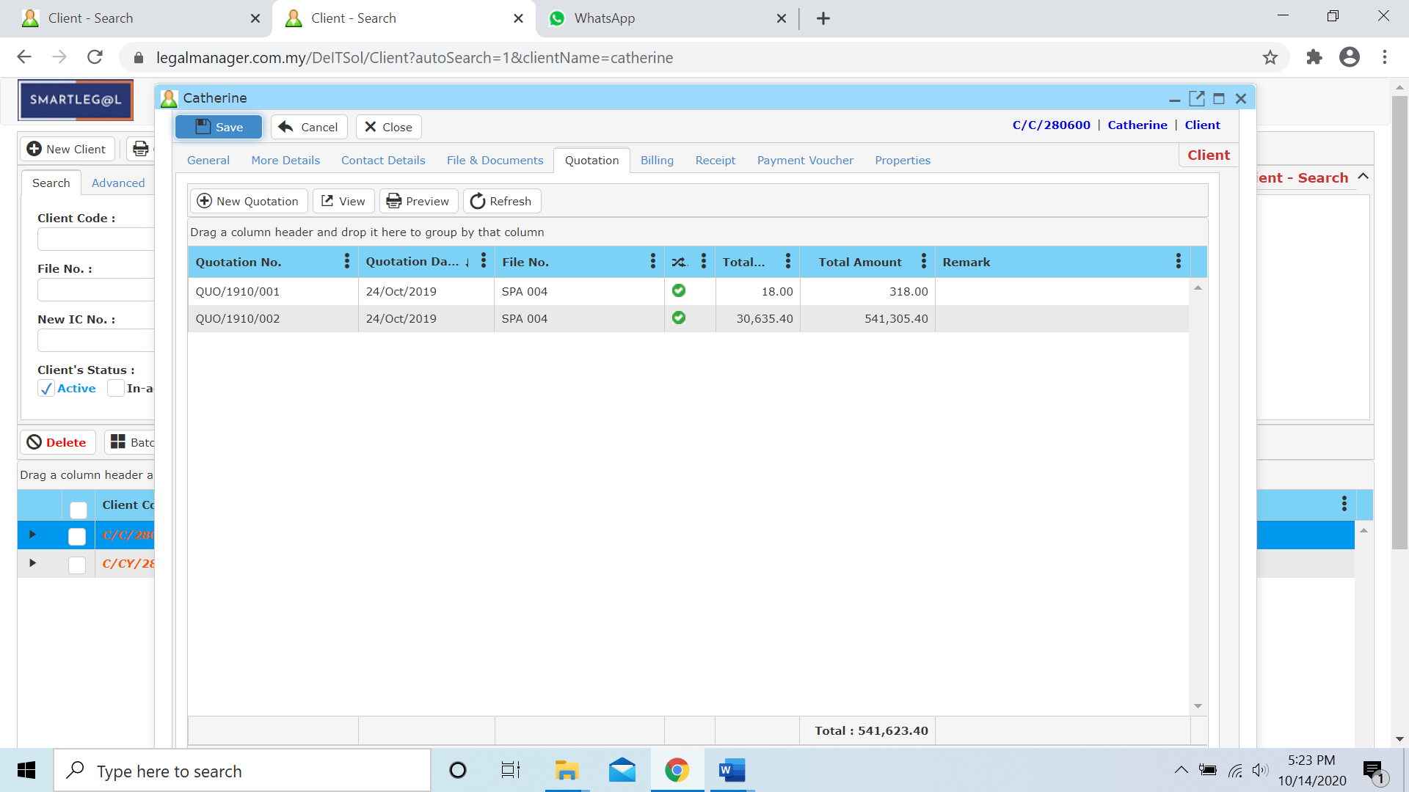

Figure: New Client – Quotation

**New Client – Billing**

* You are required to search an existing client or create a new client before adding a new bill.
* Click ‘**Billing**’ tab
* You can view, preview, view file account statement, and refresh to make sure the latest bill and preview before print or print the bill.

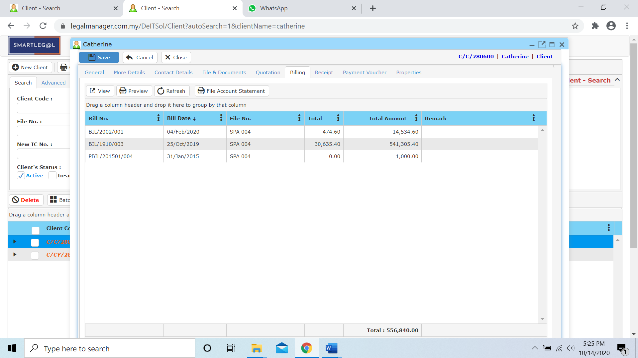

Figure: New Client – Billing

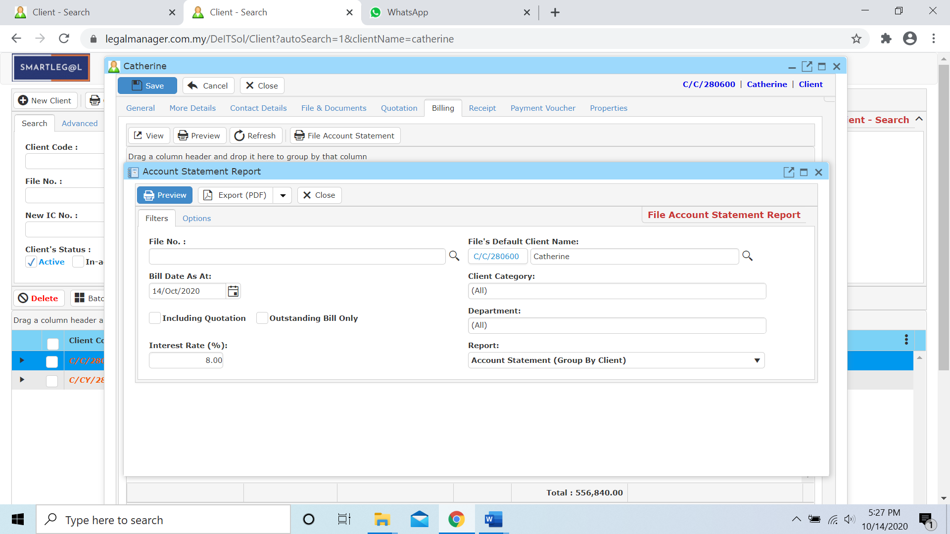

Figure: New Client – Billing – File Account Statement

**New Client – Receipt**

* You are required to search an existing client or create a new client before adding a new receipt.
* Click ‘**Receipt**’ tab
* You can add new, view, preview and refresh to make sure the latest receipt and preview before print or print the receipt.
* You can add any receipt for the client.

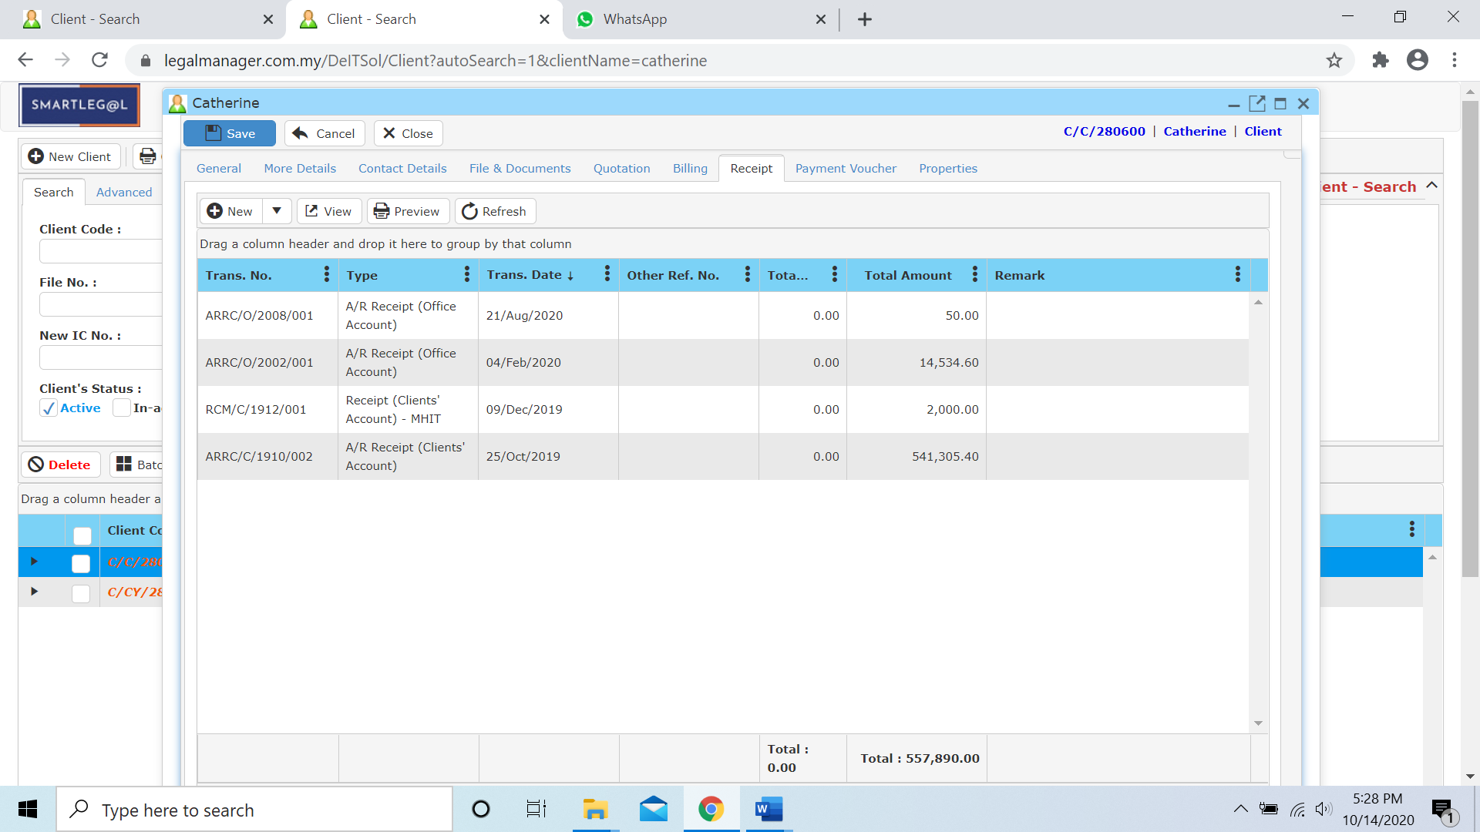

Figure: New Client – Receipt

* New receipt can be added though the selection shown by ‘Figure: New Client- Receipt – New’ below

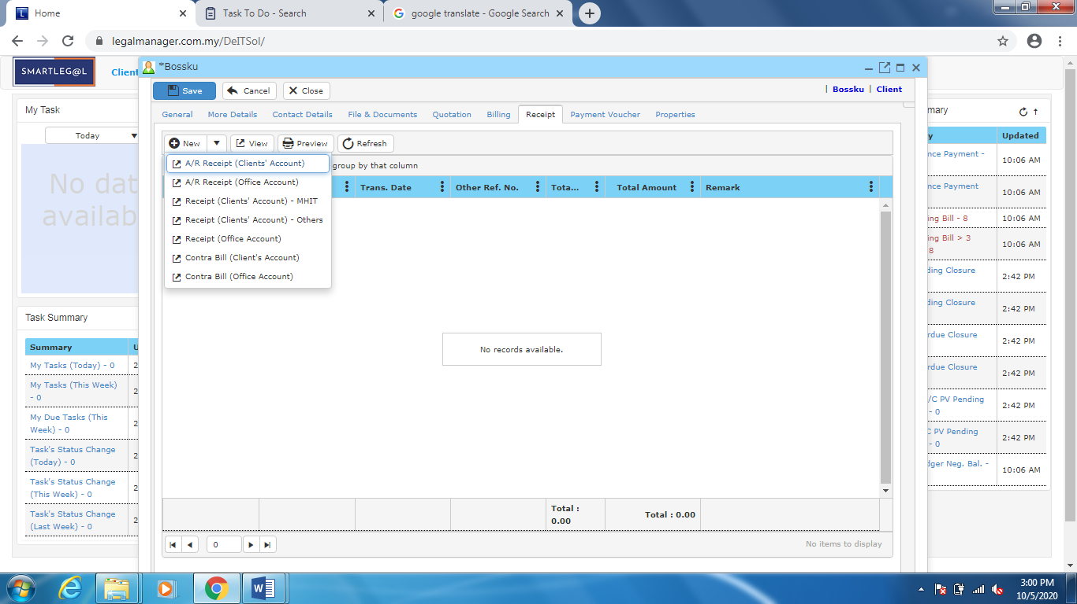

Figure: New Client – Receipt – New

**New Client – Payment Voucher**

* You are required to search an existing client or create a new client before adding a new payment voucher.
* Click ‘**Payment Voucher**’ tab.
* You can add new, view, preview and refresh to make sure the latest payment voucher and preview before print or print the payment voucher.

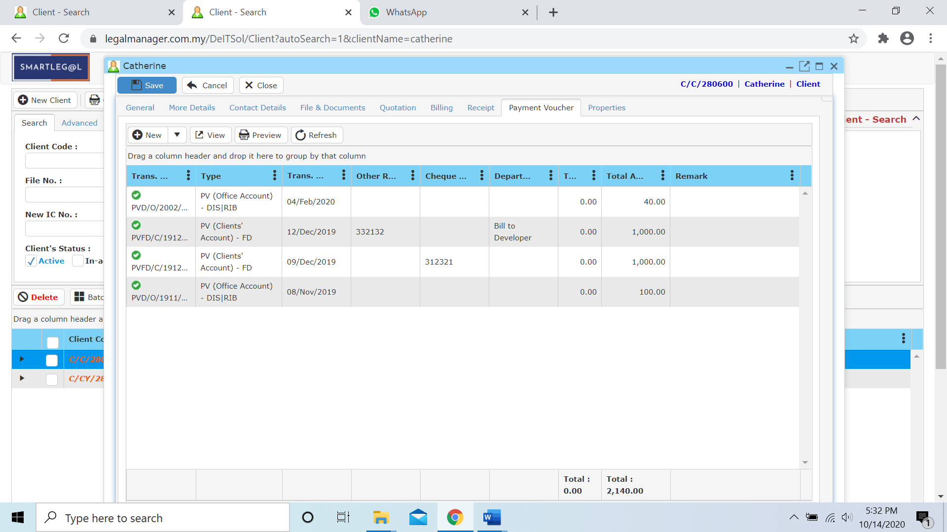

Figure: New Client – Payment Voucher

* New receipt can be added though the selection shown by ‘Figure: New Client- Payment Voucher – New’ below

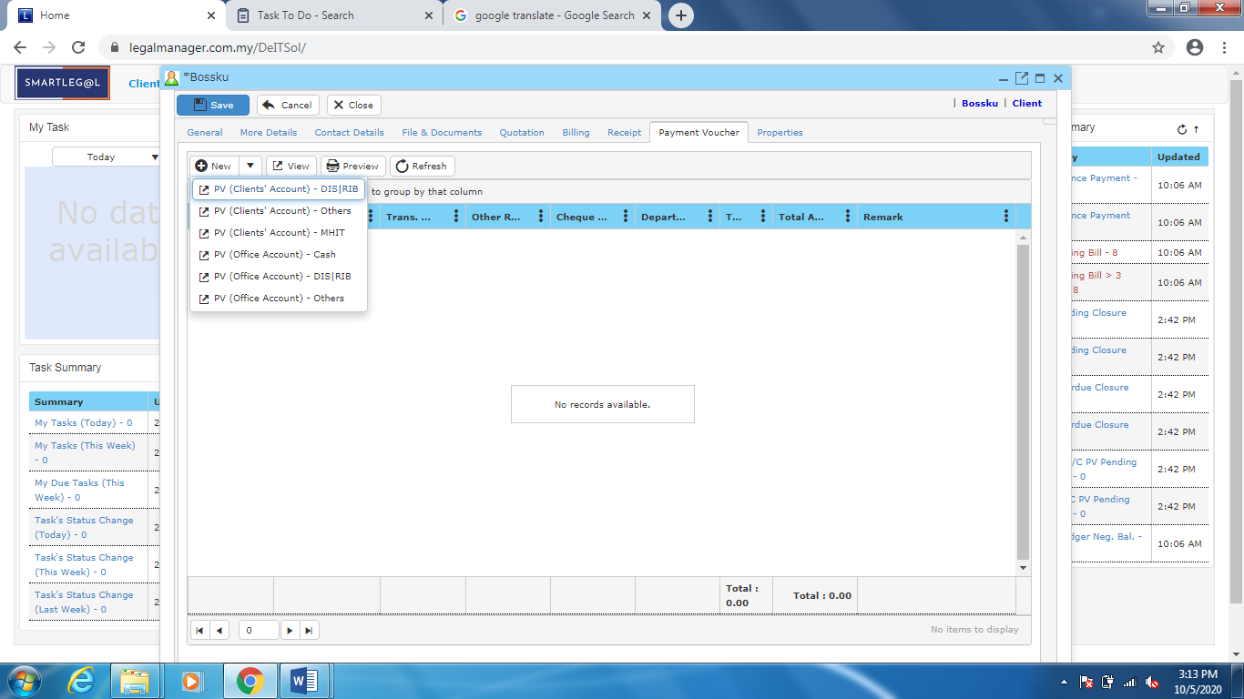

Figure: New Client – Payment Voucher – New

**New Client – Properties**

* You can view the information of the record once who modify the record then there will show the last modified and modified by who

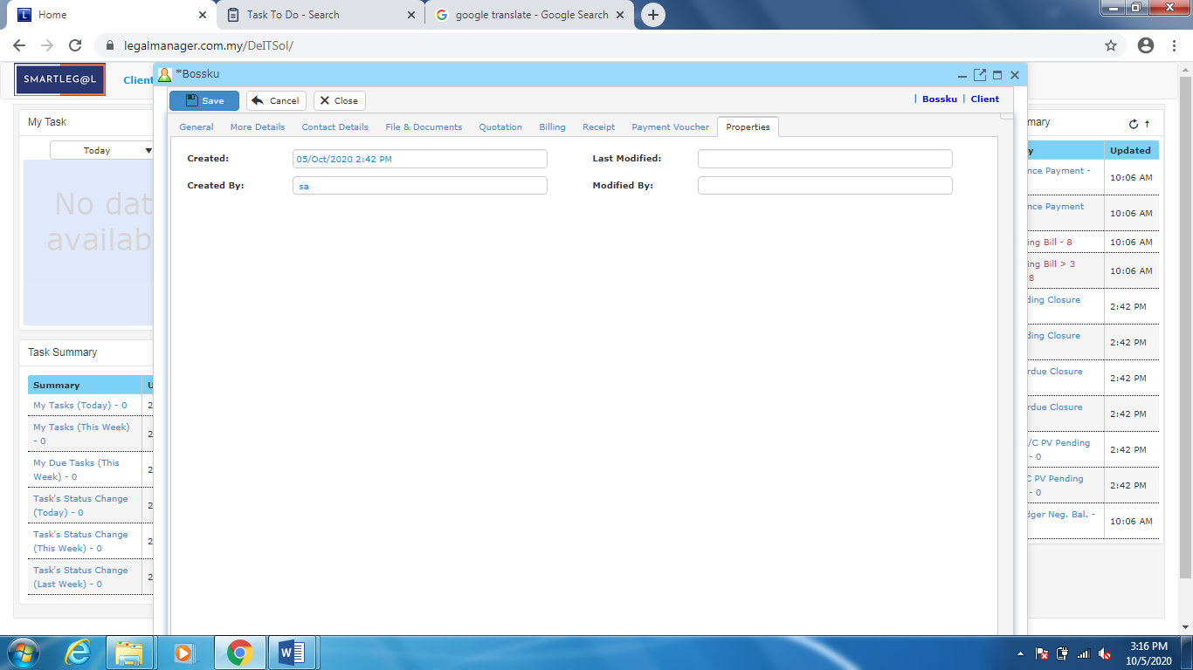

Once you finished to fill all the information, click ‘**Save**’.

Note: It is advisable to fill in the details because if those fields are being used at the mail merge function, the system will be affected when you edit the information half way.

**1.2 Manage Client**

This function enables you to modify existed customer in the system.

* To open Manage Client, on the **SmartLeg@l** navigation, click **Client** and go to **Manage Client** then search the client you want to modify.

**Manage Client**

* Search the client you wish to manage through filling client’s details or search by advanced.

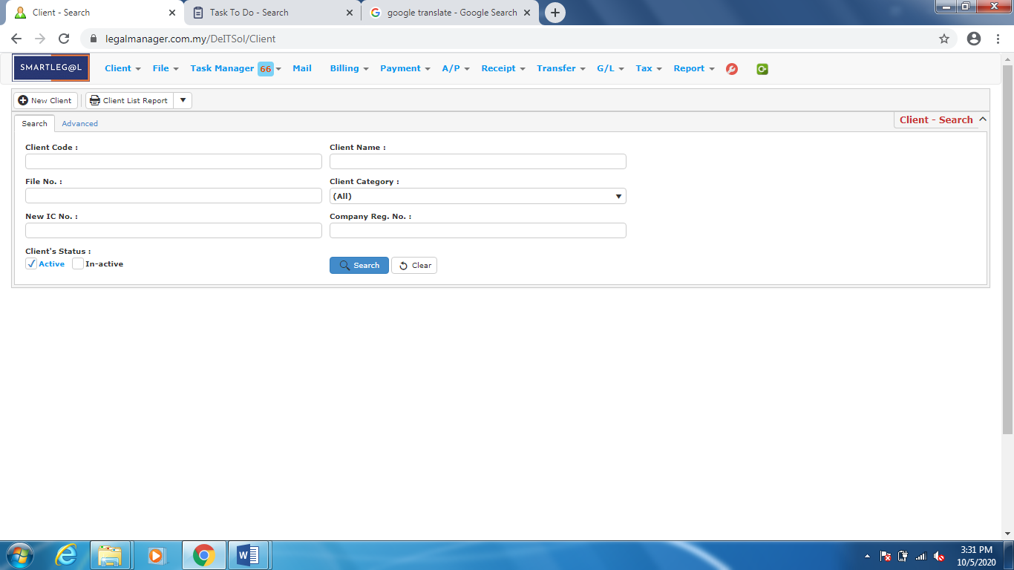

Figure: Manage Client – Search

**Advanced Find**

- This function can be used to find a client by searching other information that is not captured in the ‘General’ section.

* Click ‘**Advanced**’ tab.
* Define search criteria:
  + **Field** - Choose the field you want to search.
  + **Condition** - Search condition
  + **Value** - Type the details you want to find.
* Click ‘**Add to list**’, to define more than one criteria.
* Click ‘**Find**’, search results will be displayed at search record list. You can open an item in the search results list by double-clicking.
* To start a new search or to clear the search results, click ‘**Clear**’.
* Click ‘**Export**’ to print the desired search results in txt, excel or html format.

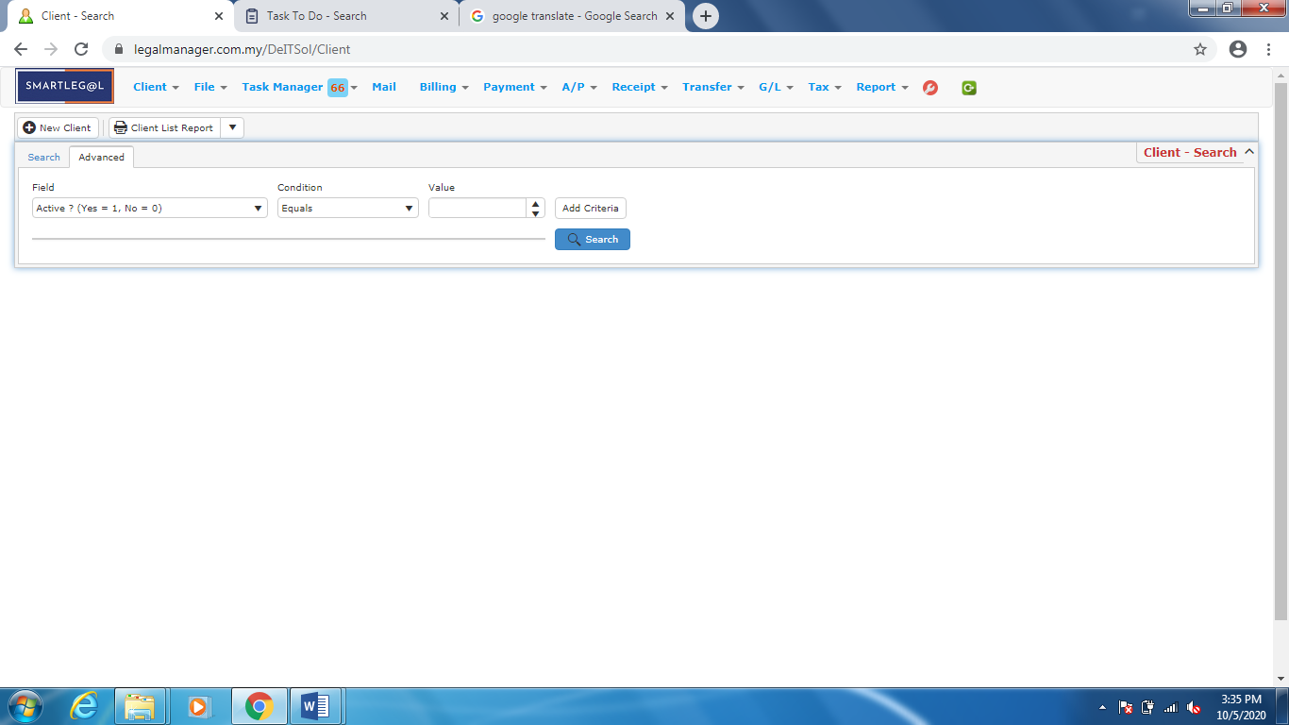

Figure: Manage Client – Advanced

Note: You can straightly type the Client Name to search the client

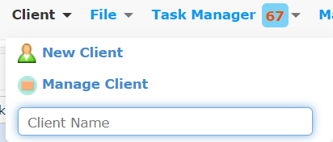

Figure: Client – Client Name

**Searched Result**

* Click ‘**Search**’ once, to show all client
* The Searched result will appeal at below, otherwise it will shown no record availble if the client you searched do not exist.
* Click ‘**Export**’ to print the desired search results in txt, excel or html format.
* Click ‘**Delete**’ to delete the selected record.

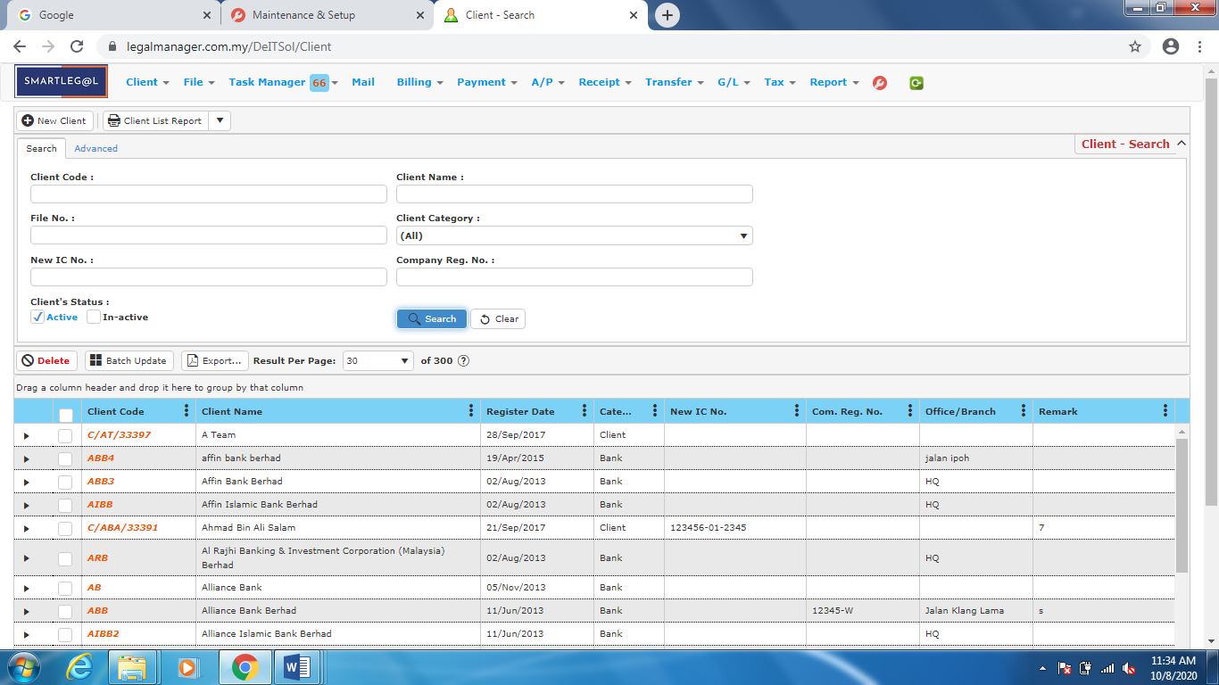

Figure: Manage Client – Search All Clients

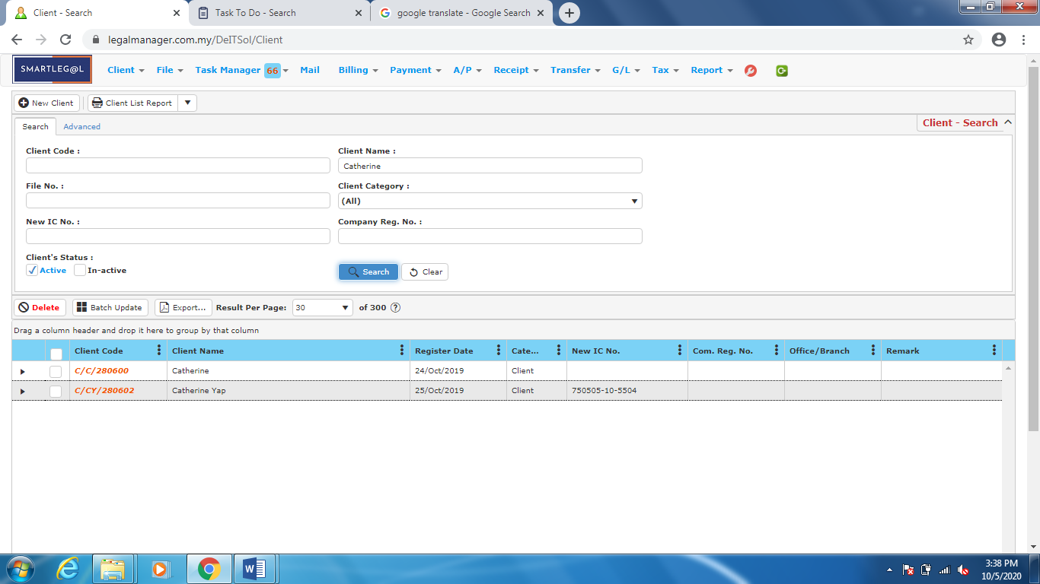

Figure: Manage Client – Search Result

* After the client you searched appeal, you can choose to view and manage to edit those details.

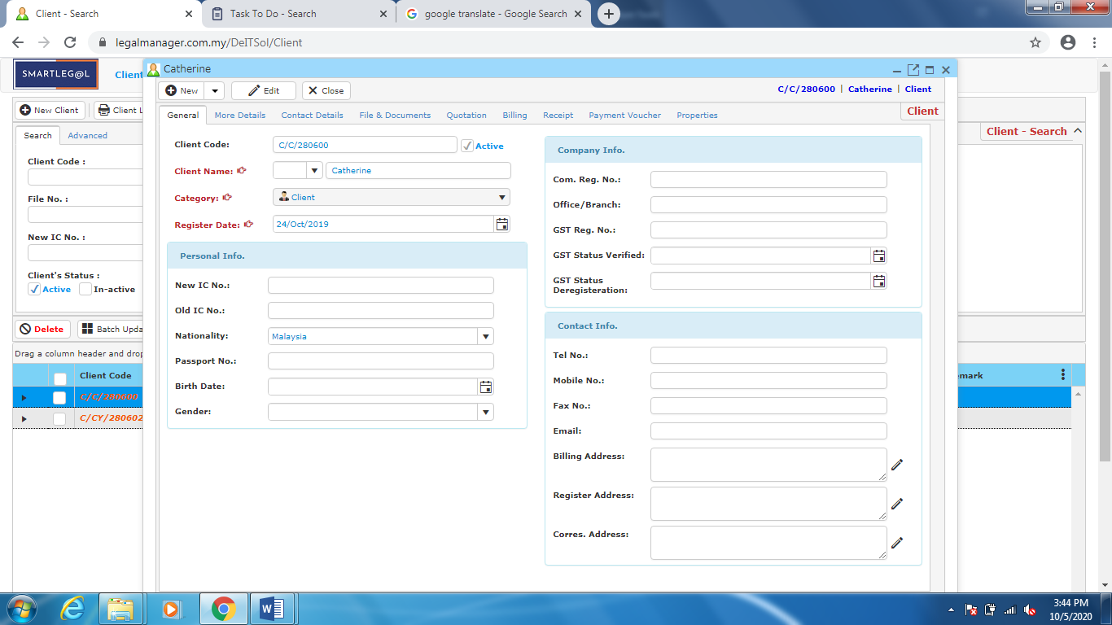

Figure: Manage Client – Search Result, Client Info